
Subject: Programming with Java
ASSIGNMENT No : 6
TITLE :Write a Java program to demonstrate the use of an inner class, an anonymous class.
Problem Statement
Write a Java program to demonstrate the use of an inner class, an anonymous class.
Learning Objectives
To implement inner classes and anonymous classes for improving encapsulation and event handling in Java.
Theory
An inner class is a class defined inside another class and has access to all members of the enclosing class, including private members. Inner classes help improve code organization and logical grouping of related classes. Anonymous classes are unnamed inner classes that are instantiated only once and are mainly used for implementing interfaces or abstract classes. They simplify code by eliminating the need for separate class definitions. These concepts are widely used in Java GUI programming and event handling
Outcome:
After completing this experiment, we learned how to create and use inner classes and anonymous classes in Java. We understood how an inner class can access the members of its enclosing class and how an anonymous class can override methods without creating a separate named class. This experiment improved our understanding of object-oriented programming concepts and code organization in Java.
Conclusion:
The experiment successfully demonstrated the implementation of inner classes and anonymous classes in Java. Inner classes helped in logically grouping related classes and accessing the members of the outer class, while anonymous classes provided a simple way to override methods without creating a separate class. These concepts improve code readability, encapsulation, and are commonly used in Java applications, especially in GUI programming and event handling.
Exercise
1.Create a Vehicle program where an inner class displays vehicle details and anonymous class performs an action.
Code:
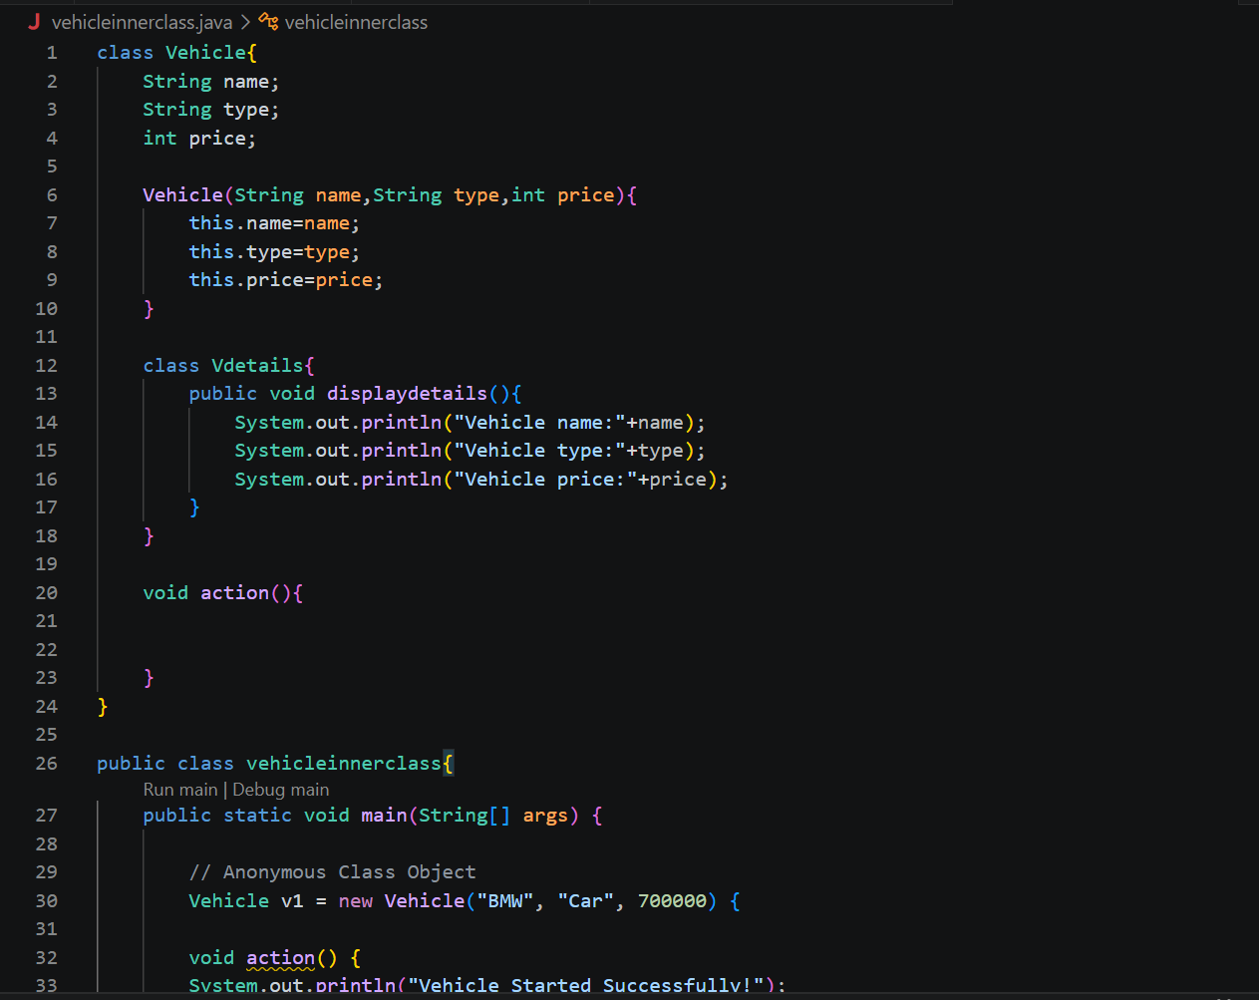

Output:
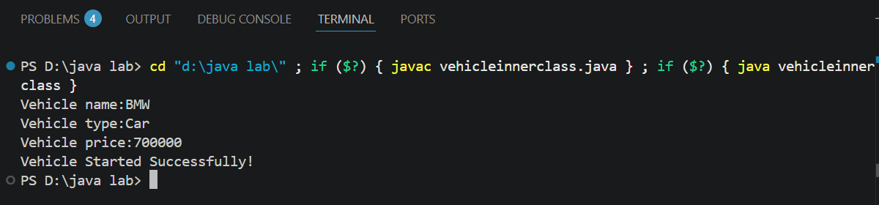

2. Develop a Food Delivery Application where an inner class handles order details and anonymous classes handle delivery status updates.
Code:
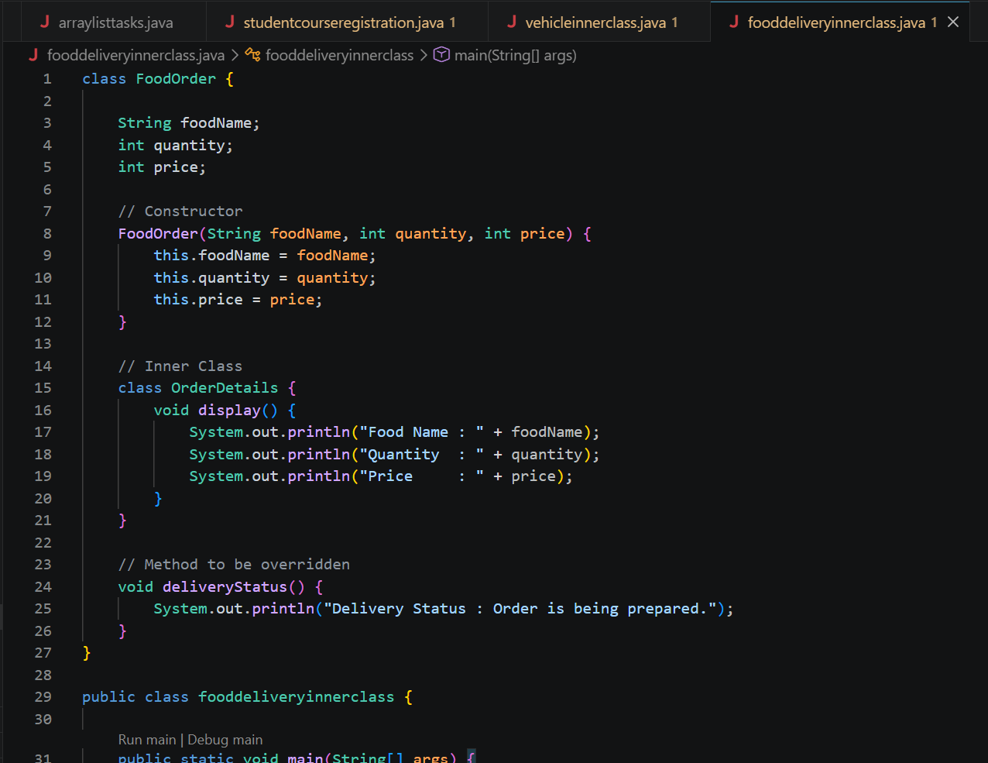
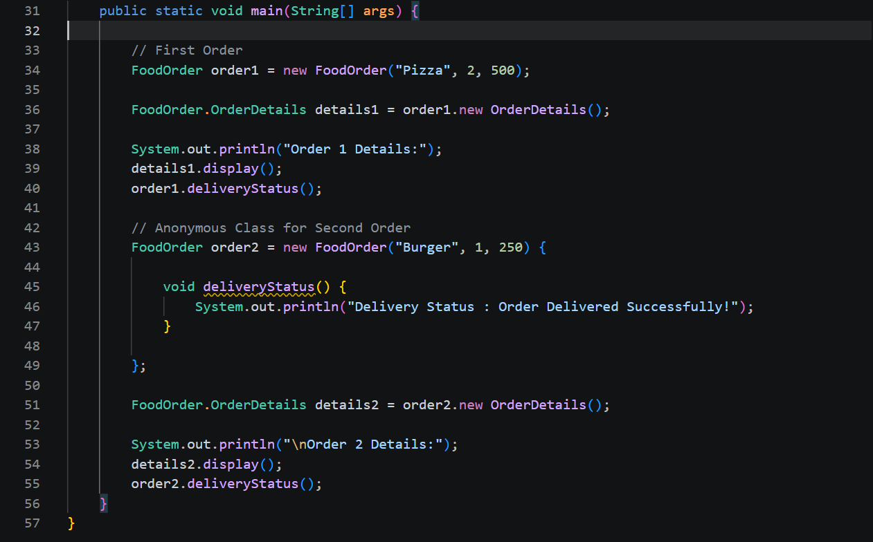
Output:
